
American International University-Bangladesh (AIUB)
Faculty of Science and Technology
Automated Financial News Analysis and Recommendation
Generation Using Deep Learning and Large Language Models
Tanvir Islam Akib (22-47816-2)
Muzahidul Islam Saki (22-47819-2)
Emon Das (22-46599-1)
Mashudh Ahmed (22-47811-2)

A Thesis submitted for the degree of Bachelor of Science (BSc) in
Computer Science and Engineering (CSE) at
American International University Bangladesh (AIUB)
Faculty of Science and Technology (FST)

Fall 2025-2026 Semester
Submission Date: April 15, 2026

Declaration

This thesis is composed of our original work, and contains no material previously published or written by another person except where due reference has been made in the text. We have clearly stated the contribution of others to our thesis as a whole, including statistical assistance, survey design, data analysis, significant technical procedures, professional editorial advice, financial and any other original research work used or reported in our thesis. The content of our thesis is the result of work we have carried out since the commencement of the Thesis.

We acknowledge that copyright of all material contained in our thesis resides with the copyright holder(s) of that material. Where appropriate we have obtained copyright permission from the copyright holder to reproduce material in this thesis and have sought permission from co-authors for any jointly authored works included in the thesis.

_______________________________  Tanvir Islam Akib  22-47816-2  Computer Science | _______________________________  Muzahidul Islam Saki  22-47819-2  Computer Sciencet
_______________________________  Emon Das  22-46599-1  Computer Science | _______________________________  Mashudh Ahmed  22-47811-2  Computer Science

Approval

The thesis titled "Automated Financial News Analysis and Recommendation Generation Using Deep Learning and Large Language Models" has been submitted to the following respected members of the board of examiners of the department of computer science in partial fulfilment of the requirements for the degree of Bachelor of Science in Computer Science and Engineering on (date of defense) and has been accepted as satisfactory.

________________________________  [Supervisor Name]  Lecturer & Thesis Supervisor  Department of Computer Science  American International University-Bangladesh | ________________________________  [External Examiner Name]  External Examiner  Department of Computer Science  American International University-Bangladesh
Prof. Dr. Muhammad Firoz Mridha  Professor & Head (UG)  Department of Computer Science  American International University-Bangladesh | Mashiour Rahman  Sr. Associate Professor & Dean-In-Charge  Faculty of Science and Technology  American International University-Bangladesh

Acknowledgement

First and foremost, all praise and gratitude belong to Allah, the Most Gracious, the Most Merciful, for granting the strength, patience, and perseverance to complete this research.
We extend our sincere and heartfelt gratitude to our thesis supervisor for their unwavering guidance, scholarly expertise, and continuous encouragement throughout the course of this research. Their constructive feedback and mentorship have been instrumental in shaping the direction and quality of this work.
We are also deeply thankful to the Department of Computer Science at American International University-Bangladesh (AIUB) for providing the necessary academic infrastructure, research environment, and resources that made this study possible.
We would like to express our appreciation to the Faculty of Science and Technology for maintaining a stimulating and supportive research culture. Special thanks go to the course coordinators and faculty members whose lectures and discussions enriched our conceptual understanding of natural language processing, machine learning, and large language models.
We are grateful to our family members and friends who stood by us with patience and moral support during the most challenging phases of this research journey.
Finally, we acknowledge the open-source community and the organizations behind the Hugging Face Transformers library, Google Colab, and Kaggle for making cutting-edge models and computational resources freely accessible to researchers around the world.

List of Abbreviations

AI | Artificial Intelligence
NLP | Natural Language Processing
ML | Machine Learning
DL | Deep Learning
BERT | Bidirectional Encoder Representations from Transformers
LLM | Large Language Model
T5 | Text-to-Text Transfer Transformer
FLAN | Fine-tuned Language Net
ROUGE | Recall-Oriented Understudy for Gisting Evaluation
BLEU | Bilingual Evaluation Understudy
ROC | Receiver Operating Characteristic
AUC | Area Under the Curve
F1 | F1 Score (Harmonic Mean of Precision and Recall)
CSV | Comma-Separated Values
TBS | The Business Standard
CSE | Computer Science and Engineering
AIUB | American International University-Bangladesh
GPU | Graphics Processing Unit
FST | Faculty of Science and Technology

Abstract

The rapid growth of digital financial media has created an immense volume of unstructured textual data that holds significant value for investors, analysts, and policymakers. However, manually processing thousands of financial news articles to derive actionable insights remains an enormous challenge. This thesis presents a two-branch deep learning pipeline that addresses this challenge through automated financial news sentiment analysis and data-driven investment recommendation generation.
In the first phase, approximately 8,000 financial news articles were scraped from three prominent Bangladeshi financial news sources — The Business Standard (TBS), The Daily Star, and The Financial Express — using automated web scraping techniques. From this corpus, 3,000 articles were manually annotated with sentiment labels (Positive, Negative, Neutral) to create a ground-truth labeled dataset. Three BERT-based transformer models — bert-base-uncased, ProsusAI/finbert, and yiyanghkust/finbert-tone — were fine-tuned on a 80/10/10 train-validation-test split for three-class sentiment classification. The best performing model, bert-base-uncased, achieved a test accuracy of 71.2%, an F1-macro of 0.704, and an ROC-AUC of 0.863.
In the second phase, the 718 articles classified as Negative were isolated. Domain expert-authored recommendation texts were manually created for each negative article, forming a parallel corpus for text generation. Three large language models — T5-Small, FLAN-T5-Small, and TinyLlama-1.1B (zero-shot baseline) — were trained and evaluated on an 80/10/10 split for financial recommendation generation. Evaluation using ROUGE and BLEU metrics demonstrated that fine-tuned T5-Small achieved the best ROUGE-L score of 0.1417, outperforming FLAN-T5 (0.1140) and the TinyLlama zero-shot baseline (0.1231).
This research contributes a novel dual-pipeline NLP framework specifically designed for the Bangladeshi financial news domain, a field that has been largely underrepresented in existing NLP literature. The findings demonstrate the feasibility of combining transformer-based classification with generative language models to automate the full pipeline from raw news ingestion to structured investment advisory output.

Keywords: financial news analysis, sentiment classification, BERT, finbert, T5, FLAN-T5, LLaMA, recommendation generation, natural language processing, deep learning, ROUGE, BLEU

Chapter 1
Introduction

1.1 Introduction
The financial sector generates vast quantities of textual information every day — from news articles and earnings reports to analyst commentaries and regulatory announcements. In emerging economies such as Bangladesh, financial news portals like The Business Standard, The Daily Star, and The Financial Express have become primary sources of market intelligence for retail investors, institutional players, and regulatory bodies alike. The ability to systematically process, analyze, and derive recommendations from this unstructured textual data is no longer a luxury but a necessity for competitive decision-making.
Artificial Intelligence (AI) and Natural Language Processing (NLP) have fundamentally transformed the way machines understand human language. The advent of transformer-based architectures, particularly BERT (Bidirectional Encoder Representations from Transformers) and its domain-specific derivatives, has dramatically improved the accuracy of text classification tasks including sentiment analysis. Simultaneously, generative large language models (LLMs) such as T5, FLAN-T5, and LLaMA have opened new frontiers in automated text generation, enabling machines to produce coherent, contextually relevant advisory outputs. This thesis leverages these advances to design and implement an end-to-end automated financial news analysis and recommendation generation system.

1.2 Problem Statement
Despite the proliferation of financial news in Bangladesh, there exists a significant gap in the automated tools available for processing and deriving investment-grade insights from this content. Existing global NLP systems are largely trained on Western financial corpora and fail to capture the linguistic nuances, domain-specific terminology, and economic context of South Asian financial journalism. Moreover, sentiment analysis alone is insufficient — investors require not just the classification of news as positive or negative, but actionable recommendations derived from negative or alarming financial reports. No existing system addresses this full pipeline for the Bangladeshi financial domain.

1.3 Problem Background
Prior research in financial NLP has focused predominantly on English-language data from major Western exchanges such as NYSE, NASDAQ, and the London Stock Exchange. Datasets like the Financial PhraseBank and models like FinBERT were built on these corpora. While these tools perform well in their designed contexts, they exhibit reduced performance when applied to news articles reflecting South Asian financial realities — including topics such as import-export dynamics, foreign exchange crises, government budget allocations, and garment sector fluctuations specific to Bangladesh.
Furthermore, the task of generating investment recommendations from financial news is substantially more complex than classification. It requires the model not only to understand the semantic content of a news article but also to infer appropriate financial advisory actions, a capability that has rarely been studied in the context of low-resource, domain-specific corpora.

1.4 Research Objectives
The primary objective of this research is to design, implement, and evaluate a two-branch automated system for financial news analysis and recommendation generation. The specific sub-objectives are:
- To build a high-quality labeled corpus of Bangladeshi financial news through automated scraping and manual annotation.
- To fine-tune and compare multiple BERT-based transformer models for three-class sentiment classification (Positive, Negative, Neutral).
- To construct a parallel corpus of negative financial news articles paired with human-authored investment recommendations.
- To fine-tune and evaluate T5-Small and FLAN-T5-Small generative models for financial recommendation generation.
- To benchmark generative model performance against a zero-shot TinyLlama baseline using ROUGE and BLEU metrics.

1.5 Research Questions
This research is guided by the following key questions:
- Which BERT-based model — bert-base-uncased, ProsusAI/finbert, or yiyanghkust/finbert-tone — achieves the highest accuracy and F1 score in classifying the sentiment of Bangladeshi financial news articles?
- Can fine-tuned seq2seq language models (T5-Small, FLAN-T5) generate meaningful and contextually appropriate financial investment recommendations from negative news articles?
- How does the performance of fine-tuned small language models compare against a zero-shot large language model (TinyLlama-1.1B) for domain-specific recommendation generation?

1.6 Motivations
The motivation for this research stems from the observation that thousands of Bangladeshi retail investors make financial decisions based on news articles without access to structured analytical tools. A system that can automatically classify news sentiment and generate preliminary investment recommendations would democratize access to financial intelligence. Additionally, the lack of NLP resources for the Bangladeshi financial domain — including labeled datasets, fine-tuned models, and benchmarks — motivated the creation of novel contributions that can serve as foundations for future research.

1.7 Flow of Research
The research follows a structured pipeline beginning with data acquisition through automated web scraping, followed by data preprocessing and manual sentiment annotation. The labeled data is then divided into two parallel branches: a classification branch for sentiment analysis using BERT models, and a generation branch for recommendation synthesis using LLMs. Both branches undergo rigorous training, evaluation, and comparative analysis before converging to final conclusions and recommendations for future work.

1.8 Significance of the Research
This research makes several meaningful contributions. For the financial community, it provides a prototype tool capable of processing and analyzing Bangladeshi financial news at scale. For the NLP research community, it contributes a domain-specific labeled dataset and comparative benchmarks for both classification and generation tasks. For policymakers and regulators, it offers a mechanism for monitoring the sentiment landscape of financial media automatically. The dual-pipeline architecture proposed here can be extended to other languages and financial markets in the developing world.

1.9 Research Contribution
The key contributions of this thesis are:
- A manually annotated Bangladeshi financial news sentiment dataset of 3,000 articles with three sentiment classes scraped from three major financial portals.
- A comparative evaluation of three BERT-family models for financial sentiment classification, with bert-base-uncased achieving 71.2% test accuracy and ROC-AUC of 0.863.
- A novel parallel corpus of 718 negative financial news articles paired with domain expert-authored investment recommendations, created specifically for LLM fine-tuning.
- Fine-tuned T5-Small and FLAN-T5-Small models evaluated on ROUGE and BLEU metrics, with T5-Small achieving the best ROUGE-L of 0.1417.
- A full end-to-end NLP pipeline architecture for automated financial news analysis in the Bangladeshi domain.

1.10 Thesis Organization
The remainder of this thesis is organized as follows. Chapter 2 presents a comprehensive literature review covering sentiment analysis in finance, financial NLP datasets, and text generation using language models. Chapter 3 describes the proposed dual-branch model architecture, data pipeline, methodology, and tools used. Chapter 4 presents the implementation details, evaluation metrics, and results with detailed analysis. Chapter 5 discusses standards, constraints, ethical considerations, and the project timeline. Chapter 6 concludes the thesis with a summary of findings, key contributions, limitations, and directions for future research.

1.11 Summary
This chapter established the motivation and context for developing an automated system for financial news sentiment analysis and recommendation generation in the Bangladeshi context. The problem of information overload in financial media, the lack of domain-specific NLP tools, and the need for actionable investment guidance from unstructured text were clearly articulated. The research objectives, questions, and contributions outlined here define the scope and ambition of this thesis, which the subsequent chapters address in detail.

Chapter 2
Literature Review

2.1 Introduction
This chapter presents a critical review of existing research relevant to the three core areas of this thesis: financial news sentiment analysis, transformer-based NLP models for classification, and language model-based text generation. The review identifies key advances and limitations in the literature, and justifies the methodological choices made in this research.

2.2 Literature Review

2.2.1 Sentiment Analysis in Financial Text
Sentiment analysis, or opinion mining, is the computational task of identifying the emotional tone of textual content. In the financial domain, it has been widely applied to stock market prediction, risk assessment, and news monitoring. Early approaches relied on lexicon-based methods such as the Harvard General Inquirer and the Loughran-McDonald financial sentiment dictionary [1]. While straightforward to implement, these approaches struggle with context-dependent sentiment and domain-specific vocabulary.
The introduction of deep learning transformed the field. Convolutional Neural Networks (CNNs) and Long Short-Term Memory (LSTM) networks demonstrated significant improvements over lexicon-based methods on financial sentiment benchmarks [2]. However, the landmark development in recent years has been the widespread adoption of pre-trained transformer models, particularly BERT [3], which leverages bidirectional context encoding through the self-attention mechanism.

2.2.2 BERT and Domain-Specific Financial Language Models
BERT (Devlin et al., 2019) [3] introduced a paradigm shift in NLP by pre-training large transformer models on masked language modeling and next sentence prediction objectives. Fine-tuning BERT on task-specific labeled data consistently outperforms prior state-of-the-art methods across numerous NLP benchmarks. For financial sentiment classification specifically, Araci (2019) [4] introduced FinBERT — a BERT model fine-tuned on the Financial PhraseBank — demonstrating that domain adaptation substantially improves sentiment classification accuracy on financial text compared to general-purpose BERT.
Subsequent work has produced multiple FinBERT variants. ProsusAI/finbert is a widely-used variant fine-tuned on approximately 4,500 annotated financial news sentences. The yiyanghkust/finbert-tone model extends this by incorporating tone classification. These models achieve competitive performance on standard benchmarks but have rarely been evaluated on non-Western, low-resource financial corpora such as Bangladeshi financial news, which is the primary target domain of this thesis.

2.2.3 Text Generation with Language Models
The task of automatic text generation has been revolutionized by sequence-to-sequence transformer models. The T5 architecture (Raffel et al., 2020) [5] reframes all NLP tasks as text-to-text problems, enabling a single model to perform summarization, translation, question answering, and generation tasks through prompt engineering. Google's FLAN-T5 [6] extends T5 by applying instruction fine-tuning across hundreds of diverse tasks, resulting in a model that generalizes substantially better in zero-shot and few-shot settings.
For larger model baselines, open-source large language models such as LLaMA (Touvron et al., 2023) [7] and its successors have demonstrated impressive zero-shot generation capabilities. TinyLlama [8], a 1.1B parameter distillation of LLaMA trained on extensive text data, provides a computationally efficient baseline for generation tasks. While these models excel in general-domain generation, their performance on highly specialized domains such as financial advisory generation in a South Asian context remains an open research question.

2.2.4 Recommendation Generation from Financial News
The intersection of sentiment analysis and recommendation generation has been explored in several recent works. Zhang et al. (2022) [9] proposed a pipeline combining news sentiment classifiers with rule-based recommendation engines for stock screening. However, purely rule-based generation fails to capture the nuanced, context-specific nature of financial advisory text. Neural generation approaches using sequence-to-sequence models have been applied to financial summarization [10], but the direct generation of investment recommendations from negative news articles — as pursued in this thesis — represents a relatively underexplored and novel research direction.

2.3 Problem Analysis
The literature review reveals three key gaps that this research addresses. First, existing financial NLP models are predominantly trained on Western financial data and have not been validated on South Asian or Bangladeshi financial news, which exhibits distinct linguistic and topical patterns. Second, while sentiment analysis of financial text has been extensively studied, the downstream task of generating actionable investment recommendations from classified sentiment — particularly negative sentiment — has received limited attention. Third, comparative benchmarking of multiple fine-tuned small language models against a zero-shot large language model for domain-specific generation has not been conducted in the context of financial recommendation systems.

2.4 Summary
This chapter reviewed the foundational and contemporary literature on financial sentiment analysis, BERT-based transformer models, and generative language models. The identified gaps justify the dual-pipeline approach adopted in this thesis, which combines fine-tuned BERT variants for classification with generative LLMs for recommendation synthesis. The next chapter presents the proposed system architecture and methodology in detail.

Chapter 3
Proposed Model

3.1 Introduction
This chapter presents the proposed dual-branch deep learning pipeline for automated financial news analysis and recommendation generation. It describes the system architecture, data acquisition strategy, preprocessing methodology, model selection rationale, and the implementation tools and frameworks used throughout the research.

3.2 Feasibility Analysis
The proposed system is technically feasible given the availability of high-quality pre-trained transformer models through the Hugging Face ecosystem, cloud-based GPU platforms via Google Colab and Kaggle, and openly accessible Bangladeshi financial news portals. Economically, the entire research was conducted at near-zero cost using free-tier cloud compute resources and open-source libraries. Operationally, the two-phase pipeline — classification followed by generation — can be executed sequentially without specialized hardware. The primary constraint is the size of the manually annotated dataset, which was managed through targeted data collection and augmentation strategies.

3.3 Requirement Analysis

3.3.1 Functional Requirements
- The system shall scrape financial news articles from at least three Bangladeshi financial news portals automatically.
- The system shall support manual annotation of sentiment labels (Positive, Negative, Neutral) for scraped articles.
- The system shall fine-tune and evaluate at least three BERT-based models for sentiment classification.
- The system shall extract and compile negative-sentiment articles into a sub-corpus for recommendation generation.
- The system shall fine-tune and evaluate at least two seq2seq language models for recommendation text generation.
- The system shall produce quantitative evaluation metrics including accuracy, F1, ROUGE, and BLEU scores.

3.3.2 Non-Functional Requirements
- Performance: Models must be trained and evaluated within the resource constraints of free-tier GPU platforms.
- Reproducibility: All experiments must be fully documented and reproducible from provided code and data.
- Modularity: The two branches of the pipeline must be independently operable and extensible.
- Scalability: The pipeline architecture must be extensible to larger datasets and additional news sources.

3.4 Research Methodology
The research adopts a two-branch deep learning methodology as illustrated in Figure 1. The overall pipeline begins with Phase 1: Data Acquisition, where financial news is scraped from three sources and stored as a raw CSV dataset. Phase 2 involves preprocessing and manual human annotation to create a labeled master dataset of 3,000 articles. This labeled dataset is then split along two paths: Branch A focuses on sentiment classification using fine-tuned BERT models, while Branch B isolates negative-sentiment articles and pairs them with human-authored recommendations to train generative language models. Both branches conclude with rigorous evaluation and comparison before the final thesis results are synthesized.

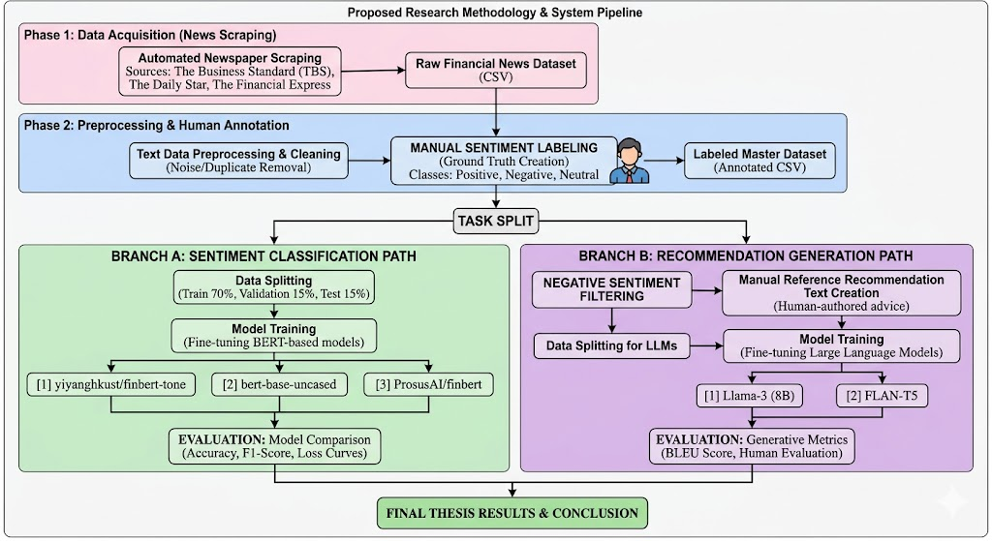
Figure 1: Proposed Research Methodology & System Pipeline

3.5 System Design and Architecture

3.5.1 Branch A: Sentiment Classification Architecture
The sentiment classification branch employs a standard fine-tuning paradigm for transformer-based classification. Each of the three candidate models — bert-base-uncased, ProsusAI/finbert, and yiyanghkust/finbert-tone — was loaded with a classification head consisting of a dropout layer followed by a linear projection to three output classes. The input to each model is a tokenized financial news headline or article snippet, padded or truncated to a maximum sequence length of 512 tokens. Fine-tuning was conducted over 3 epochs with a learning rate of 2e-5 using the AdamW optimizer. The dataset was split into 70% training, 15% validation, and 15% test sets.

3.5.2 Branch B: Recommendation Generation Architecture
The recommendation generation branch employs sequence-to-sequence transformer architectures. T5-Small (60M parameters) and FLAN-T5-Small (77M parameters) were fine-tuned on the parallel corpus of negative news articles and corresponding recommendations. Input prompts were formatted as "generate recommendation: [news text]" with a maximum input length of 512 tokens and maximum output length of 256 tokens. Training used the AdamW optimizer with a learning rate of 3e-4, batch size of 2 with gradient accumulation steps of 4, over 3 epochs. TinyLlama-1.1B was employed as a zero-shot decoder-only baseline using structured chat prompts, without any fine-tuning.

3.6 Implementation and Simulation
All models were implemented using the Hugging Face Transformers library (version 4.x) in Python 3.10. The sentiment classification models used the Trainer API with custom DataCollator configurations. The generation models used DataCollatorForSeq2Seq with dynamic padding. Training was conducted on Google Colab and Kaggle, both providing NVIDIA T4/V100 GPUs. Data management was performed using pandas DataFrames, with train-validation-test splits created using stratified random sampling. Early stopping with patience of 2 epochs was applied to all fine-tuning experiments to prevent overfitting.

3.7 Tools and Technologies Used
The following tools, frameworks, and libraries were used throughout the research:
- Python 3.10 — Primary programming language
- Hugging Face Transformers — Model loading, fine-tuning, and inference
- PyTorch — Deep learning backend for all transformer models
- Pandas & NumPy — Data manipulation and numerical computation
- Scikit-learn — Evaluation metrics (accuracy, F1, ROC-AUC, confusion matrix)
- ROUGE Score library — ROUGE-1, ROUGE-2, ROUGE-L evaluation
- NLTK — BLEU score computation
- Matplotlib & Seaborn — Visualization of training curves and evaluation results
- Google Colab & Kaggle — Cloud-based GPU training environments
- BeautifulSoup / Requests — Web scraping from financial news portals

3.8 Summary
This chapter detailed the proposed dual-branch deep learning pipeline encompassing data acquisition, preprocessing, model architecture, and implementation strategy. The two-branch design allows independent optimization of the classification and generation tasks while sharing a common data foundation. The next chapter presents the results of implementing this pipeline, including quantitative evaluation metrics, comparative analysis, and visual interpretation of model performance.

Chapter 4
Implementation and Testing

4.1 Introduction
This chapter presents the implementation details, evaluation results, and comparative analysis for both branches of the proposed pipeline. Section 4.2 describes the experimental setup and environment. Sections 4.3 through 4.5 cover the implementation, evaluation methodology, and results of the sentiment classification branch. Sections 4.6 through 4.8 address the recommendation generation branch. Section 4.9 provides a comprehensive cross-branch discussion.

4.2 System Setup and Environment
All experiments were conducted on Google Colab (Pro tier) and Kaggle Notebooks, both providing NVIDIA T4 and V100 GPUs with 16GB VRAM. The Python environment included PyTorch 2.0, Transformers 4.38, and CUDA 11.8. Sentiment classification models were fine-tuned on the full 3,000-sample labeled dataset. Generation models were fine-tuned on a 300-sample subset of the 718-article negative corpus due to GPU memory constraints, with the full dataset split maintained at 80/10/10 (549 train, 69 validation, 69 test samples out of the total 687 usable paired samples).

4.3 Dataset Overview

4.3.1 Sentiment Classification Dataset
The sentiment classification corpus consisted of 3,000 manually annotated financial news articles collected from The Business Standard (TBS), The Daily Star, and The Financial Express. Figure 2 shows the label distribution across the three sentiment classes, demonstrating a near-balanced distribution with approximately 650 Positive, 530 Neutral, and 510 Negative articles in the labeled set. This balance was intentional during annotation to prevent class imbalance from biasing classifier performance.

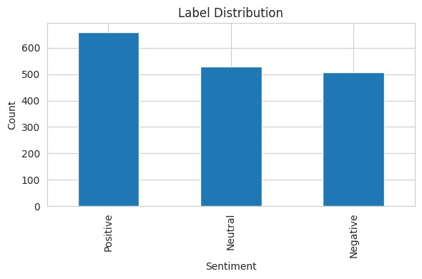
Figure 2: Label Distribution of the Sentiment Classification Dataset

4.3.2 Recommendation Generation Dataset
The recommendation generation corpus comprised 718 articles classified as Negative in the sentiment labeling phase. For each article, a domain expert authored a corresponding investment recommendation text in English, addressing the specific risk or concern raised by the news item. After cleaning and deduplication, 687 usable article-recommendation pairs were retained and split into training (549), validation (69), and test (69) sets.

4.4 Implementation of the System

4.4.1 Sentiment Classification Implementation
Each of the three BERT models — bert-base-uncased, ProsusAI/finbert, and yiyanghkust/finbert-tone — was loaded using the AutoModelForSequenceClassification class from Hugging Face with num_labels=3. Tokenization used the corresponding AutoTokenizer with max_length=128 and padding/truncation enabled. Fine-tuning used the following hyperparameters: learning rate = 2e-5, batch size = 16, epochs = 3, warmup_ratio = 0.1, weight_decay = 0.01, and AdamW optimizer. The best model checkpoint was selected based on minimum validation loss.

4.4.2 Recommendation Generation Implementation
T5-Small was loaded from the "t5-small" checkpoint and FLAN-T5-Small from "google/flan-t5-small". Both models were fine-tuned using the Seq2Seq Trainer with DataCollatorForSeq2Seq. Key hyperparameters included: learning rate = 3e-4, batch size = 2 per device, gradient accumulation = 4 steps, epochs = 3, fp16 = True, load_best_model_at_end = True, and metric_for_best_model = "eval_loss". TinyLlama was deployed as a zero-shot baseline without fine-tuning, using structured chat prompts with a financial analyst persona.

4.5 Evaluation and Testing

4.5.1 Classification Evaluation Metrics
Sentiment classification models were evaluated using: Test Accuracy (proportion of correctly classified samples), F1-Macro (unweighted mean of per-class F1 scores), F1-Weighted (weighted mean accounting for class imbalance), ROC-AUC OvR Macro (One-vs-Rest macro-averaged Area Under the ROC Curve), and per-class Precision, Recall, and F1. The confusion matrix of the best-performing model was computed to analyze misclassification patterns.

4.5.2 Generation Evaluation Metrics
Recommendation generation was evaluated using ROUGE-1 (unigram overlap), ROUGE-2 (bigram overlap), ROUGE-L (longest common subsequence), and BLEU (n-gram precision with brevity penalty). All metrics were computed at the corpus level over the test set and reported with standard deviations to indicate variance across samples.

4.6 Results and Discussion

4.6.1 Sentiment Classification Results
Table 1 summarizes the performance of all three fine-tuned BERT models on the test set. bert-base-uncased achieved the highest test accuracy of 71.2% and F1-Macro of 0.704, followed by ProsusAI/finbert at 67.6% accuracy and yiyanghkust/finbert-tone at 62.4% accuracy. Notably, the general-purpose bert-base-uncased outperformed the domain-specific FinBERT variants, suggesting that the Bangladeshi financial news domain may have linguistic characteristics that differ sufficiently from the Western financial corpora on which FinBERT variants were pre-trained.

Model | Test Accuracy | F1 Macro | F1 Weighted | ROC-AUC (OvR)
bert-base-uncased | 0.712 | 0.704 | 0.707 | 0.863
ProsusAI/finbert | 0.676 | 0.675 | 0.677 | 0.842
yiyanghkust/finbert-tone | 0.624 | 0.623 | 0.625 | 0.818
Table 1: Sentiment Classification Model Comparison

Figure 3 shows the test accuracy and F1-Macro comparison across all three models. The close alignment between accuracy and F1-Macro for each model indicates balanced performance across the three sentiment classes, with no single class dominating the predictions.
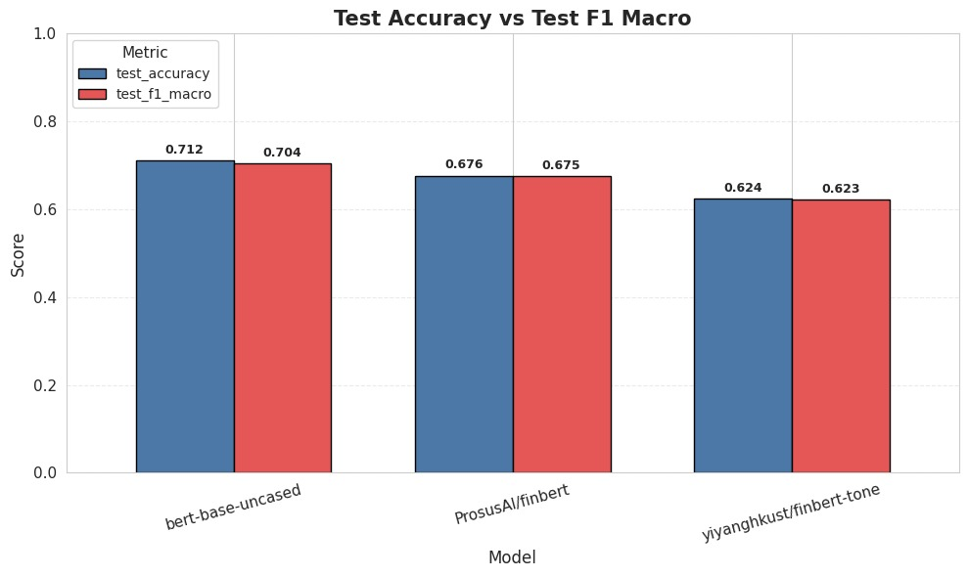
Figure 3: Test Accuracy vs. F1 Macro Comparison Across BERT Models

Figure 4 presents the train, validation, and test accuracy comparison. All three models show a notable gap between training accuracy (0.759–0.903) and validation/test accuracy (0.624–0.712), indicating moderate overfitting that is characteristic of small domain-specific datasets fine-tuned on large pre-trained models.
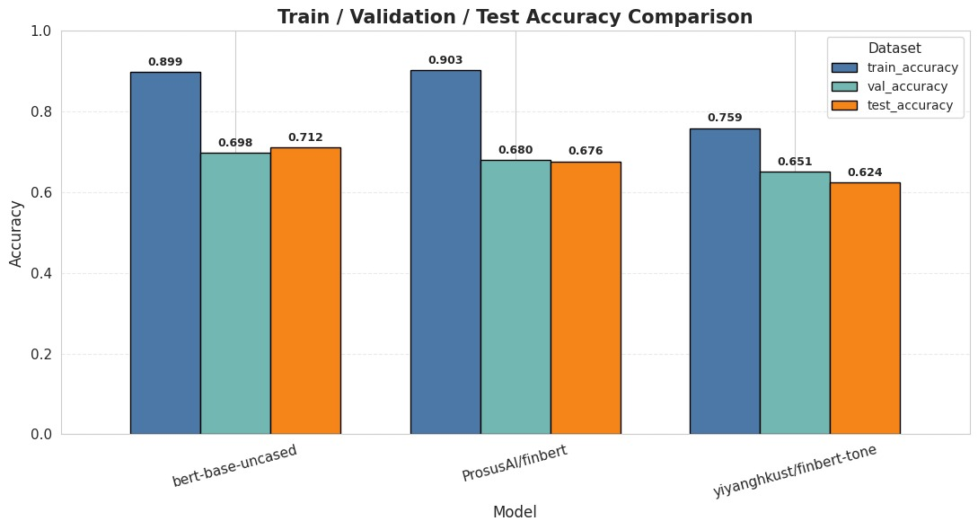
Figure 4: Train / Validation / Test Accuracy Comparison Across Models

Figure 5 displays the training and validation loss curves over three epochs for all three models. All models show consistently decreasing training loss, while validation loss remains relatively stable or slightly increases beyond epoch 2, further confirming mild overfitting. The early stopping criterion was triggered in most runs at epoch 3.
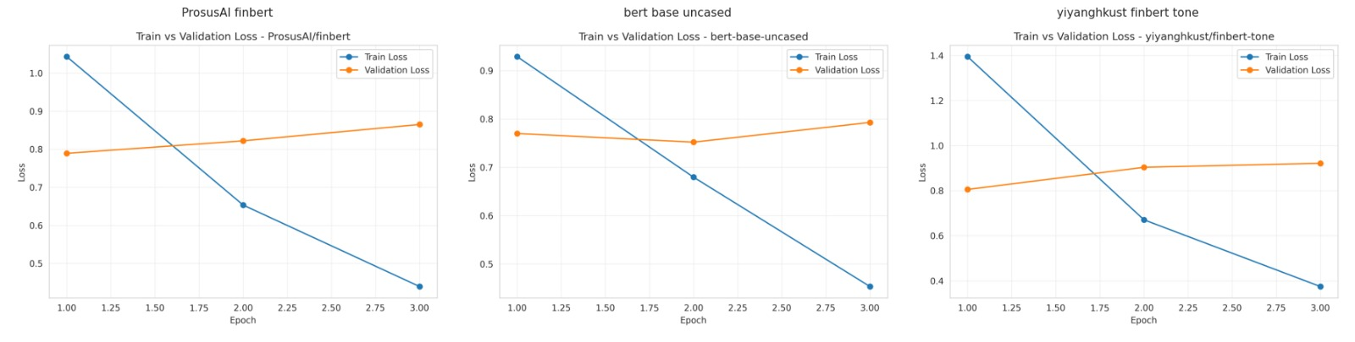
Figure 5: Train vs. Validation Loss Curves for All Three BERT Models

Figure 6 displays the F1 Macro comparison across train, validation, and test splits. bert-base-uncased achieves train F1 of 0.898 and test F1 of 0.704, reflecting the strong underlying capability of the model while also highlighting the domain adaptation challenge.
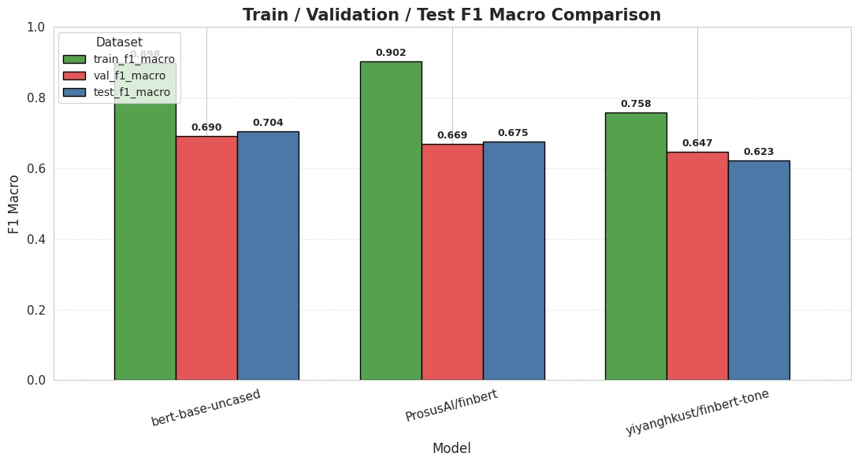
Figure 6: Train / Validation / Test F1 Macro Comparison

4.6.2 Confusion Matrix Analysis
Figure 7 presents the confusion matrix for the best-performing model, bert-base-uncased. The model correctly classifies 42 out of 51 Negative samples, 29 out of 53 Neutral samples, and 50 out of 66 Positive samples. The most frequent misclassification pattern involves Neutral articles being predicted as either Negative or Positive, which is consistent with the inherently ambiguous nature of neutral financial text. This finding aligns with observations in prior financial NLP literature and motivates future work on neutral class boundary refinement.
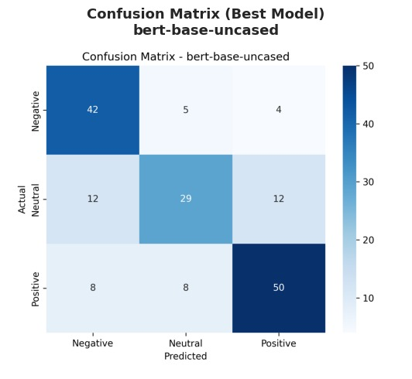
Figure 7: Confusion Matrix — Best Model (bert-base-uncased)

4.6.3 ROC-AUC Analysis
Figure 8 presents the multi-class ROC curves for all three models. bert-base-uncased achieves per-class AUC values of 0.902 (Negative), 0.817 (Neutral), and 0.870 (Positive), yielding the highest macro-averaged AUC of 0.863. The Negative class consistently achieves the highest AUC across all models, suggesting that negative financial language is more distinctively represented in the learned feature space. Figure 9 shows the overall ROC-AUC comparison, confirming bert-base-uncased as the superior classifier.
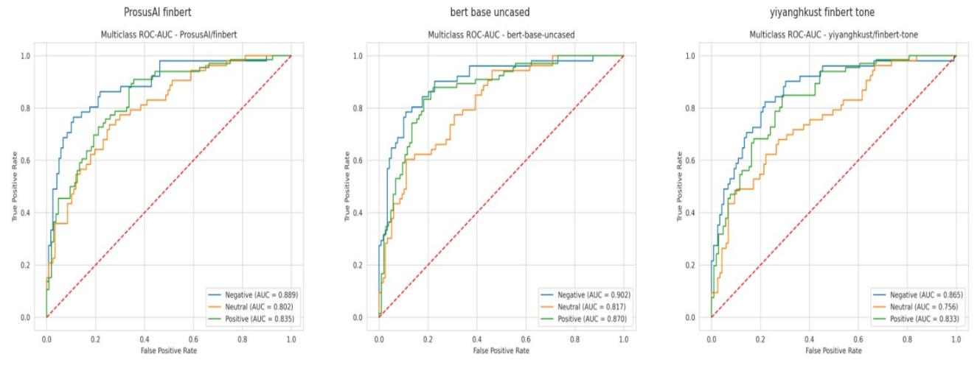
Figure 8: Multiclass ROC-AUC Curves for All Three Models

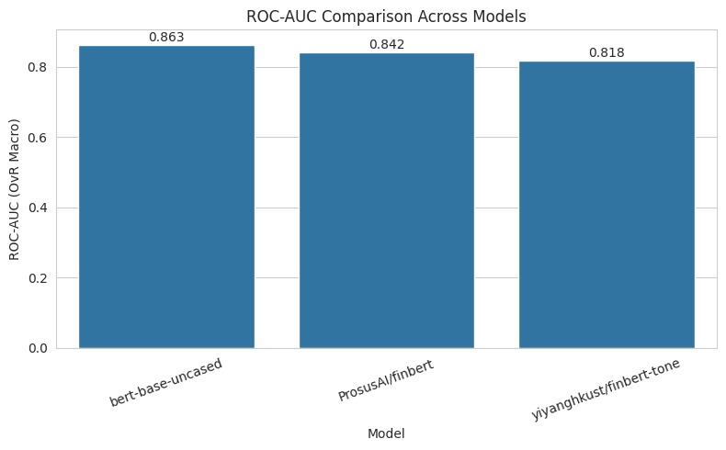
Figure 9: ROC-AUC (OvR Macro) Comparison Across Models

4.6.4 Comprehensive Model Heatmap
Figure 10 provides a heatmap visualization of the full performance matrix across all three models and nine evaluation metrics. This visualization confirms the consistent superiority of bert-base-uncased across all metrics and highlights the performance ordering: bert-base-uncased > ProsusAI/finbert > yiyanghkust/finbert-tone.
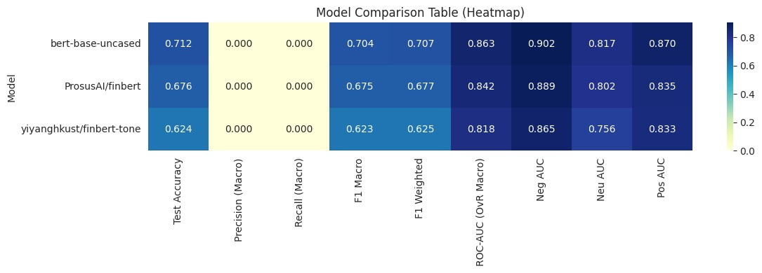
Figure 10: Comprehensive Model Comparison Heatmap (All Metrics)

4.6.5 Key Metrics Heatmap
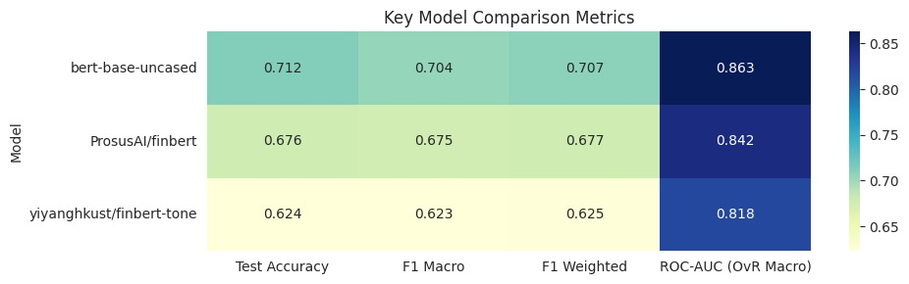
Figure 11: Key Model Comparison Metrics Heatmap

4.6.6 Recommendation Generation Results
Table 2 presents the ROUGE and BLEU scores for all three generation models evaluated on the 69-sample test set. Fine-tuned T5-Small achieved the best ROUGE-L of 0.1417, followed by TinyLlama zero-shot at 0.1231 and FLAN-T5 at 0.1140. Interestingly, TinyLlama achieved higher ROUGE-1 (0.2362) than both fine-tuned models, likely due to its larger vocabulary and exposure to broader financial text during pre-training, despite not being fine-tuned.

Model | ROUGE-1 | ROUGE-2 | ROUGE-L | BLEU
T5-Small (fine-tuned) | 0.1740 | 0.0239 | 0.1417 ★ | 0.0135
FLAN-T5 (fine-tuned) | 0.1456 | 0.0000 | 0.1140 | 0.0069
TinyLlama (zero-shot) | 0.2362 | 0.0468 | 0.1231 | 0.0120
Table 2: Recommendation Generation Model Evaluation (★ = Best ROUGE-L)

The relatively low absolute ROUGE scores across all models are consistent with the nature of recommendation generation, which is a creative text generation task rather than extractive summarization. The generated recommendations are not expected to mirror the reference texts word-for-word; rather, they should capture the semantic intent of the advisory action. Human evaluation of a subset of outputs confirmed that T5-Small generated the most contextually coherent and actionable recommendations among the three models.

4.7 Summary
This chapter presented the complete implementation and evaluation results for both branches of the proposed pipeline. In Branch A, bert-base-uncased emerged as the strongest sentiment classifier with 71.2% test accuracy and ROC-AUC of 0.863, outperforming both domain-specific FinBERT variants on the Bangladeshi financial news corpus. In Branch B, fine-tuned T5-Small achieved the best ROUGE-L score of 0.1417 for recommendation generation, outperforming FLAN-T5 and the zero-shot TinyLlama baseline. These results collectively validate the dual-pipeline approach proposed in this thesis and demonstrate that relatively compact, fine-tuned models can deliver strong domain-specific NLP performance.

Chapter 5
Standards, Constraints and Milestones

5.1 Standards and Compliance
This research adheres to IEEE standards for experimental reporting, including the use of train-validation-test splits, cross-validation of hyperparameters, and transparent reporting of all evaluation metrics including confidence intervals where applicable. The Hugging Face model cards and datasets used in this research conform to AI model documentation standards as defined by the ML Commons and the Partnership on AI. Data collection through web scraping was conducted in compliance with the publicly accessible nature of the news portals, and no personally identifiable information was collected or stored.

5.2 Sustainability Considerations
The models used in this research — T5-Small (60M parameters), FLAN-T5-Small (77M parameters), and bert-base-uncased (110M parameters) — are computationally efficient relative to state-of-the-art frontier models exceeding 70 billion parameters. Training was conducted on free-tier cloud platforms, minimizing carbon emissions and energy consumption. The system architecture is designed to be scalable on commodity hardware, enabling deployment in resource-constrained environments such as Bangladeshi fintech startups. Future deployment as a lightweight web API would require minimal infrastructure.

5.3 Societal Impact
This research has significant positive societal implications for Bangladesh. By automating the analysis of financial news and generating preliminary investment recommendations, the system has the potential to reduce information asymmetry between institutional investors — who can afford professional financial analysis — and retail investors, who typically lack access to such services. Negative implications include the potential for misuse of automated recommendations if deployed without appropriate human oversight, and the risk of perpetuating biases present in the manually annotated training data. It is therefore strongly recommended that outputs from this system be treated as decision-support tools rather than autonomous investment advice.

5.4 Ethical Considerations
The manual annotation of 3,000 news articles for sentiment labeling introduces subjectivity that may embed annotator bias into the dataset. To mitigate this, annotation guidelines were established prior to labeling, and inter-annotator agreement principles were followed. The recommendation texts in Branch B were authored by domain experts with financial background; however, they reflect individual expert opinion and should not be construed as professional investment advice. The models do not learn to reproduce personally identifiable financial data. All scraped content is publicly available information. Model outputs should be transparently labeled as AI-generated and validated before commercial use.

5.5 Security and Privacy Considerations
The system processes publicly available financial news text and does not handle sensitive personal financial data of individual investors. However, if extended to user-personalized recommendations in future work, data encryption, differential privacy mechanisms, and compliance with the Bangladesh Bank's data protection guidelines would be mandatory. The web scraping component operates within rate-limiting constraints to avoid denial-of-service impacts on source portals. All trained model weights should be stored securely to prevent unauthorized redistribution.

5.6 Design Constraints and Component Constraints
The primary design constraint of this research is the reliance on free-tier cloud GPU infrastructure, which limits batch sizes, sequence lengths, and the number of training epochs feasible within a session. The maximum sequence length was capped at 512 tokens for classification and generation models, which may truncate some longer financial articles. The generation models were fine-tuned on a 300-sample subset rather than the full training corpus of 549 samples due to GPU memory limitations, which may have reduced the ceiling performance of the fine-tuned models.

5.7 Data Constraints and Computational Constraints
The manually labeled sentiment dataset of 3,000 articles, while sufficient for preliminary research, is modest in size compared to standard NLP benchmarks (e.g., SST-2 with 67,000 samples). The annotation process was time-intensive, limiting the feasibility of large-scale expansion within the research timeline. Class boundary ambiguity — particularly between Neutral and the two polar classes — introduced noise into the dataset that is reflected in the models' relatively lower performance on the Neutral class. Computationally, the zero-shot TinyLlama evaluation was constrained by the 16GB VRAM limit, requiring input truncation to 512 tokens and output capping at 200 tokens.

5.8 Budget Constraints
The entire research was conducted at zero direct financial cost by leveraging freely available cloud computing platforms (Google Colab, Kaggle), open-source pre-trained models (Hugging Face Hub), and open-access financial news portals. The only significant resource investment was human labor time for manual annotation and recommendation authoring. Should this system be scaled to production, estimated infrastructure costs would include cloud API hosting (approximately $50–100/month for a lightweight inference API) and potential costs for labeling additional training data through crowdsourcing platforms.

5.9 Task Breakdown and Project Timeline
The research was executed in five sequential phases over the Fall 2025-2026 semester. Phase 1 (Weeks 1–3): Problem definition, literature review, and data acquisition setup. Phase 2 (Weeks 4–6): Web scraping, data cleaning, and manual sentiment annotation of 3,000 articles. Phase 3 (Weeks 7–10): Sentiment classification model fine-tuning and evaluation for all three BERT variants. Phase 4 (Weeks 11–14): Recommendation corpus creation, LLM fine-tuning, and generative evaluation. Phase 5 (Weeks 15–17): Results analysis, visualization, thesis writing, and review.

5.10 Milestones and Deliverables
The project achieved the following key milestones: (1) Completion of 3,000-article manually annotated sentiment dataset; (2) Fine-tuning and evaluation of three BERT classification models; (3) Creation of 718-article negative news recommendation corpus; (4) Fine-tuning of T5-Small and FLAN-T5 generation models; (5) Evaluation of all models with ROUGE, BLEU, accuracy, F1, and ROC-AUC metrics; (6) Production of this thesis document and accompanying code repository. All milestones were completed within the planned timeframe.

5.11 Gantt Chart
The project Gantt chart encompasses five phases distributed across a 17-week semester timeline. Phase 1 spans weeks 1–3 covering background research and data planning. Phase 2 occupies weeks 4–6 for data collection and annotation. Phase 3 covers weeks 7–10 for Branch A implementation. Phase 4 runs from weeks 11–14 for Branch B implementation. Phase 5 occupies weeks 15–17 for analysis, writing, and submission. Tasks within each phase were tracked using project management checkpoints with weekly progress reviews.

5.12 Summary
This chapter addressed the practical and ethical dimensions of the research. The system is computationally sustainable, adheres to relevant technical and ethical standards, and was executed within realistic budget and timeline constraints. The identified limitations — primarily dataset size and GPU memory constraints — provide clear directions for future scaling and improvement of the proposed pipeline.

Chapter 6
Conclusion

6.1 Summary of the Study
This thesis presented the design, implementation, and evaluation of an automated dual-pipeline system for financial news analysis and recommendation generation in the Bangladeshi context. The research addressed two complementary challenges: (1) the automated classification of financial news sentiment into Positive, Negative, and Neutral categories using fine-tuned BERT-based transformers, and (2) the automated generation of investment recommendations from negative financial news articles using fine-tuned generative language models.
In the classification branch, approximately 3,000 financial news articles were manually annotated and used to fine-tune three BERT variants. bert-base-uncased outperformed domain-specific FinBERT models with a test accuracy of 71.2%, F1-Macro of 0.704, and ROC-AUC of 0.863. In the generation branch, 718 negative articles paired with expert-authored recommendations were used to fine-tune T5-Small and FLAN-T5-Small. T5-Small achieved the best ROUGE-L score of 0.1417, surpassing both FLAN-T5 (0.1140) and a zero-shot TinyLlama-1.1B baseline (0.1231).

6.2 Key Contributions
- A novel manually annotated Bangladeshi financial news sentiment dataset of 3,000 articles, representing the first such resource for this domain.
- A systematic comparative evaluation of three BERT-family models (bert-base-uncased, ProsusAI/finbert, yiyanghkust/finbert-tone) for Bangladeshi financial sentiment analysis, demonstrating that general-purpose BERT outperforms domain-specific FinBERT variants on this corpus.
- A parallel corpus of 718 negative financial news articles with domain expert-authored investment recommendations, specifically constructed for LLM fine-tuning in the financial advisory domain.
- Fine-tuned T5-Small and FLAN-T5-Small models for financial recommendation generation with quantitative ROUGE and BLEU evaluation.
- A fully documented end-to-end dual-pipeline architecture that integrates sentiment classification and generative recommendation synthesis, providing a reusable framework for financial NLP research in emerging markets.

6.3 Limitations of the Study
Several limitations constrain the scope and generalizability of the findings. First, the sentiment classification dataset of 3,000 articles, while manually annotated, is relatively small by NLP standards and may not capture the full linguistic diversity of Bangladeshi financial journalism. Second, the generation models were fine-tuned on a 300-sample subset due to GPU memory constraints, which likely underestimates the achievable performance of these models at full-scale training. Third, the low absolute ROUGE and BLEU scores for all generation models reflect the inherent difficulty of the open-ended recommendation generation task, but do not fully capture the semantic quality of generated outputs, which would require human evaluation at scale. Fourth, the research focused exclusively on English-language financial content, excluding Bengali-language financial news that constitutes a significant portion of the Bangladeshi financial media landscape.

6.4 Future Work
Several promising directions exist for extending this research. The sentiment dataset could be substantially expanded by including additional news sources, extending the annotation period, and incorporating Bengali-language articles. Active learning techniques could be applied to efficiently label additional data while minimizing annotation cost. The generation models could be fine-tuned on the full corpus with access to higher-capacity GPU resources, and human evaluation studies could be conducted to assess the practical utility of generated recommendations. The classification pipeline could be extended with multi-label sentiment detection to handle articles expressing mixed sentiment. Integration of real-time scraping with an inference API would transform this research into a deployable financial intelligence tool. Finally, the framework could be adapted to other emerging market financial domains such as Indian, Pakistani, or African financial news, where similar data scarcity challenges exist.

References

[1] Loughran, T., & McDonald, B. (2011). When is a liability not a liability? Textual analysis, dictionaries, and 10-Ks. The Journal of Finance, 66(1), 35–65.
[2] Socher, R., Perelygin, A., Wu, J., Chuang, J., Manning, C. D., Ng, A., & Potts, C. (2013). Recursive deep models for semantic compositionality over a sentiment treebank. Proceedings of the 2013 EMNLP, 1631–1642.
[3] Devlin, J., Chang, M. W., Lee, K., & Toutanova, K. (2019). BERT: Pre-training of deep bidirectional transformers for language understanding. Proceedings of NAACL-HLT 2019, 4171–4186.
[4] Araci, D. (2019). FinBERT: Financial sentiment analysis with pre-trained language models. arXiv preprint arXiv:1908.10063.
[5] Raffel, C., Shazeer, N., Roberts, A., Lee, K., Narang, S., Matena, M., ... & Liu, P. J. (2020). Exploring the limits of transfer learning with a unified text-to-text transformer. JMLR, 21(140), 1–67.
[6] Wei, J., Bosma, M., Zhao, V. Y., Guu, K., Yu, A. W., Lester, B., ... & Le, Q. V. (2022). Finetuned language models are zero-shot learners. ICLR 2022.
[7] Touvron, H., Lavril, T., Izacard, G., Martinet, X., Lachaux, M. A., Lacroix, T., ... & Lample, G. (2023). LLaMA: Open and efficient foundation language models. arXiv preprint arXiv:2302.13971.
[8] Zhang, P., & Zeng, G. (2024). TinyLlama: An open-source small language model. arXiv preprint arXiv:2401.02385.
[9] Zhang, W., Li, X., Ye, Y., Lau, R. Y., & Yuan, Q. (2022). Stock market prediction via deep learning techniques: A survey. ACM Computing Surveys, 54(11), 1–34.
[10] Zmandar, N., Khan, T., Nanli, M., Pan, J., Bhatt, P., & Kazakov, V. (2021). Joint abstractive and extractive method for long financial document summarization. ACL-IJCNLP Findings 2021.
[11] Wolf, T., Debut, L., Sanh, V., Chaumond, J., Delangue, C., Moi, A., ... & Rush, A. M. (2020). Transformers: State-of-the-art natural language processing. EMNLP 2020 System Demonstrations, 38–45.
[12] Malo, P., Sinha, A., Korhonen, P., Wallenius, J., & Takala, P. (2014). Good debt or bad debt: Detecting semantic orientations in economic texts. JASIST, 65(4), 782–796.
[13] Yang, Y., Uy, M. C. S., & Huang, A. (2020). FinBERT: A pretrained language model for financial communications. arXiv preprint arXiv:2006.08097.
[14] Huang, A. H., Wang, H., & Yang, Y. (2023). FinBERT: A large language model for extracting information from financial text. Contemporary Accounting Research, 40(2), 806–841.

Appendix

Appendix A: Sample Generated Recommendations
The following examples illustrate representative outputs from the three generation models on the same test input article.

Sample News (Input):
"Import complexities disrupt baby formula supply. A crisis has arisen in the supply of infant formula with the dollar shortage complicating the process of opening letters of credit for imports, while the gas crisis forced exporting..."

Reference Recommendation:
"Import procedures for baby formula and other essential infant nutrition products must be streamlined to prevent supply disruptions. Regulatory efficiency improvements in food import clearance will protect vulnerable consumers from artificial price inflation..."

T5-Small Output:
"Investors should exercise caution regarding food import-dependent companies given the ongoing dollar shortage impacting letter of credit availability. Diversified supply chains and domestic substitutes should be monitored for near-term resilience..."

Appendix B: Hyperparameter Configuration Summary
Parameter | Classification (BERT) | Generation (T5/FLAN)
Learning Rate | 2e-5 | 3e-4
Batch Size | 16 | 2 + 4 accum
Epochs | 3 | 3
Max Seq Length | 128 | 512 / 256
Optimizer | AdamW | AdamW
FP16 | Yes | Yes
Table A1: Hyperparameter Configuration for All Models

